**Instructions on**

**Navigating the Client Program for KV Food Service**

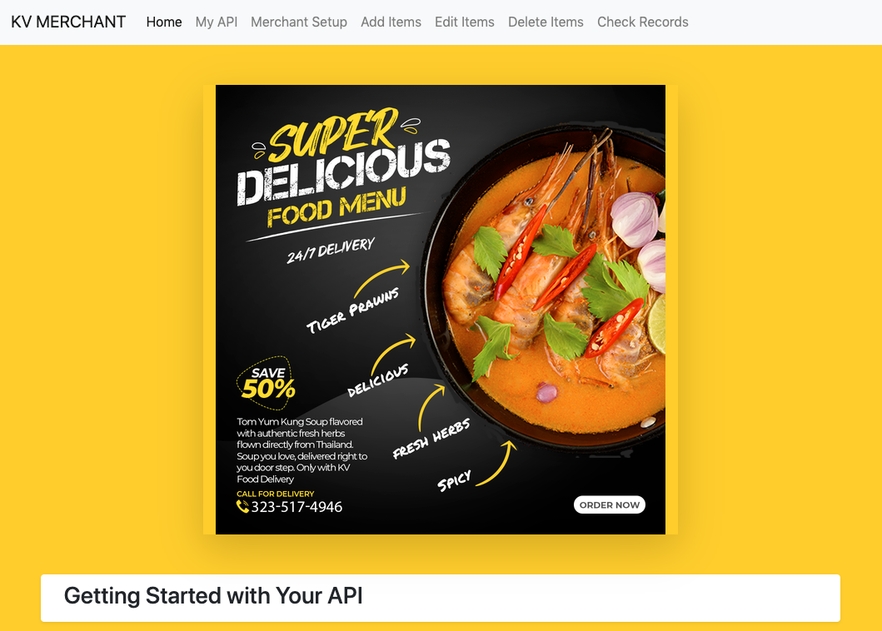

1. **Setting up the Back-end Web Server**

Please ensure that you have already read through and finished setting up the back-end web server guide. Without those prerequisites, you will be unable to fully test the client program.

Once ready, CD into the directory where you unzipped the file and the following commands in your terminal:

*go run .*

1. **Launch the Client Website**

You can use a client such as chrome to access the server at your local address:

*localhost:8080*

There is no need for a http:// or https:// right in front of the link.

1. **Start with your API key**

Accessing the program requires you to already have a valid account at the server's address.

You can also find instructions on how to find your access key on the client's home page.

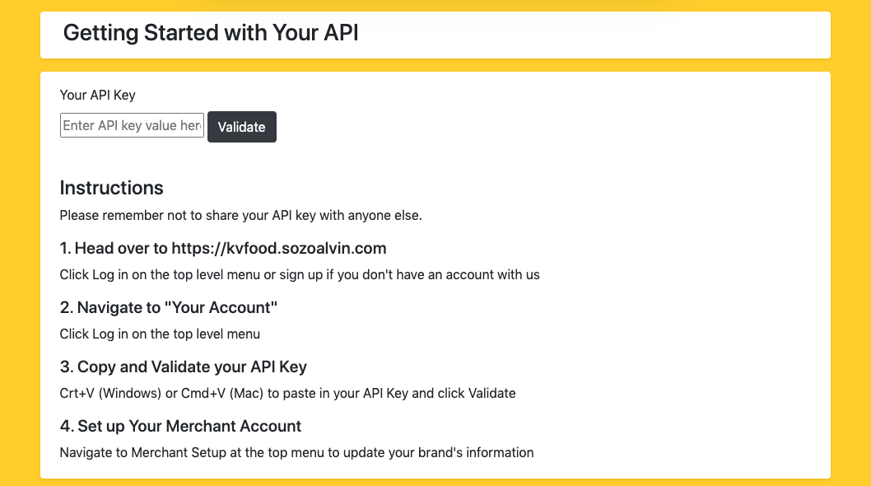

If you head over to the main server's address; you can find the top menu item called *My Account*. Clicking on that will reveal your API key.

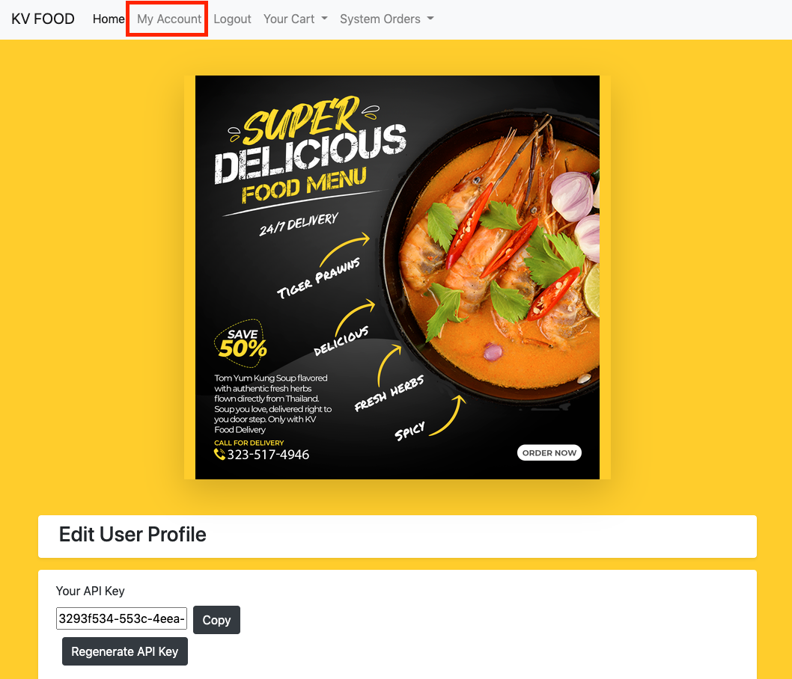

If you feel that your API key has been leaked before; please **change** it immediately. You can do that by clicking on the *Regenerate API key.*

Once you *copy* the API key, return back to the client's server and *paste (crt+v [windows] or cmd + v [mac] )* and click on **validate**.

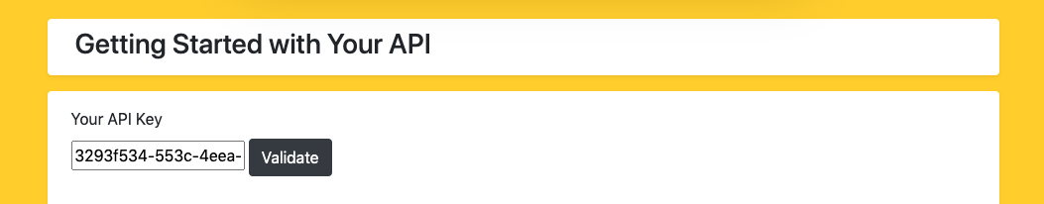

The server validates your API key against the stored data; and proceeds with returning you a successful message if the API key is valid.

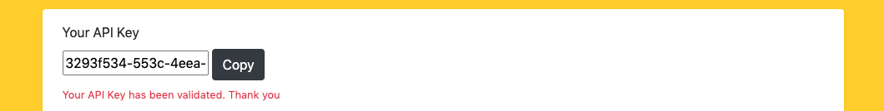

1. **Set Up Your Merchant Account**

*If you are using a #superuser account. You will have nothing to set up. You can skip this step.*

Please feel free to use any details you like; but please bear in mind that algorithms are in place to *escape string, len/length check/number validation* etc.

Alternatively, please feel free to use the placeholder values.

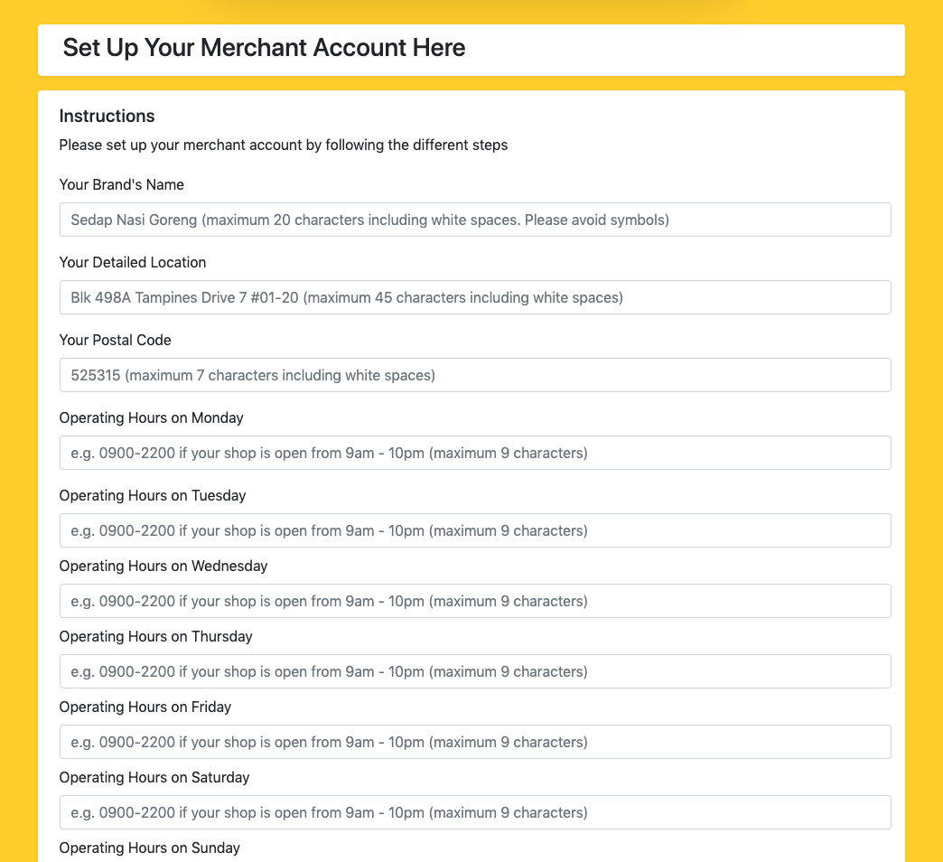

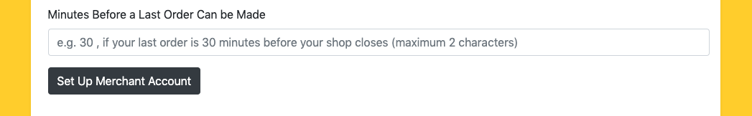

After you're done, please click on the button to submit your Merchant Account. If you're successful, you will now gain access to the other parts of the client's program. In other words, you will be able to add items, edit items as well as delete items.

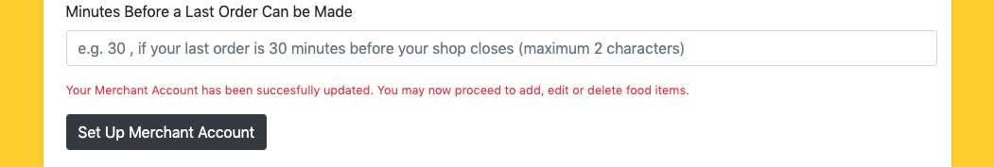

1. **Adding New Food Items**

For the next few steps, we'll be using the top menu to navigate between Add, Edit, Delete and Check Records.



The add feature is relatively straight forward. Just enter your details and follow the instructions.

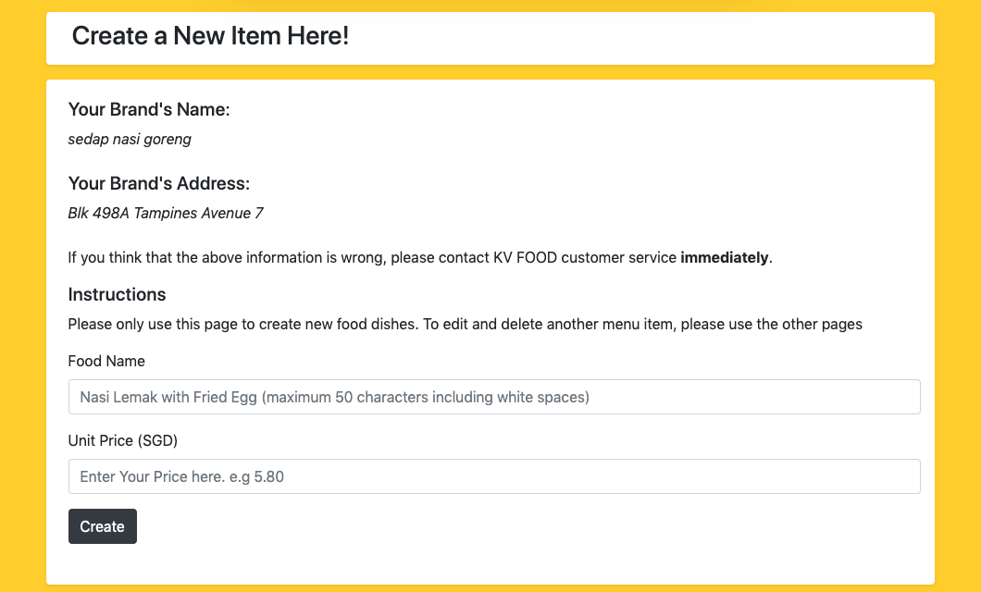

We're going to try typing the values proposed by the placeholder values and then hit the create button.

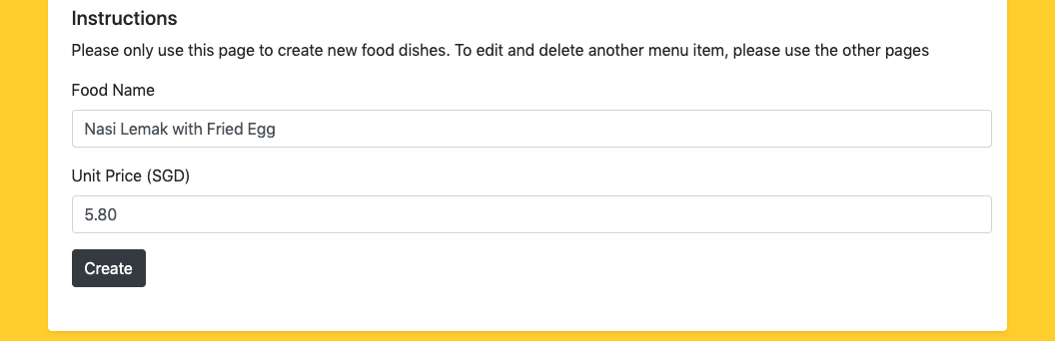

If the food item is not a duplicate or an existing food item, the client comes back with a successful message, indicating that the creation is successful and is "pending for approval".

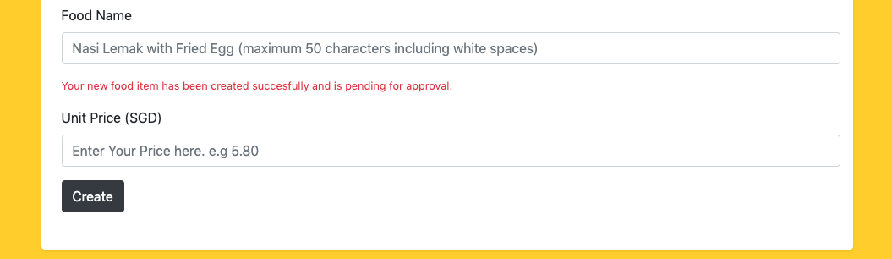

For the purpose of testing the client, I did not gate the changes. In other words, all creation, edit and delete are **immediate**. Any delay in such processes can and should be attributed to latency issues. In a real world scenario, updates / creation should still be vetted/ gated before available for purchase etc.

1. **Order your New Food Item!**

Head back to the web server (localhost) and search for whatever you just inserted. In our case, we're going to search for nasi and let the auto-complete do its job.

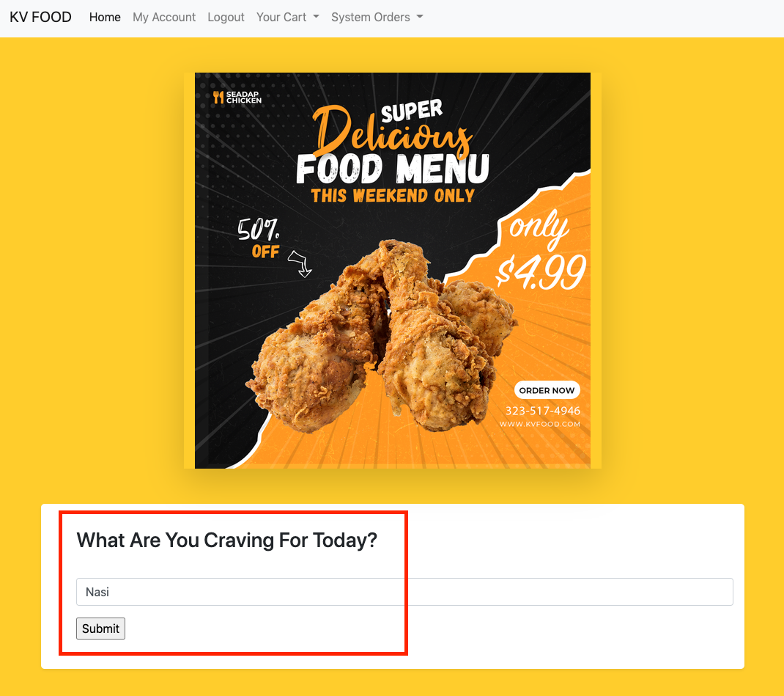

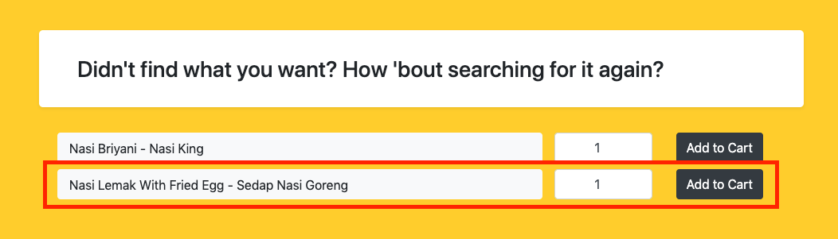

And that's it! The item you added was successful and people can start searching and adding your delicious new menu item into their cart! That wasn't so difficult was it!

1. **Editing Dish Name and Price**

Editing a dish's name as well as the price is as simple as navigating to the Edit Items menu. You'll be presented with all the dishes that you can edit. This page will **only display** menu items that belong to your account.

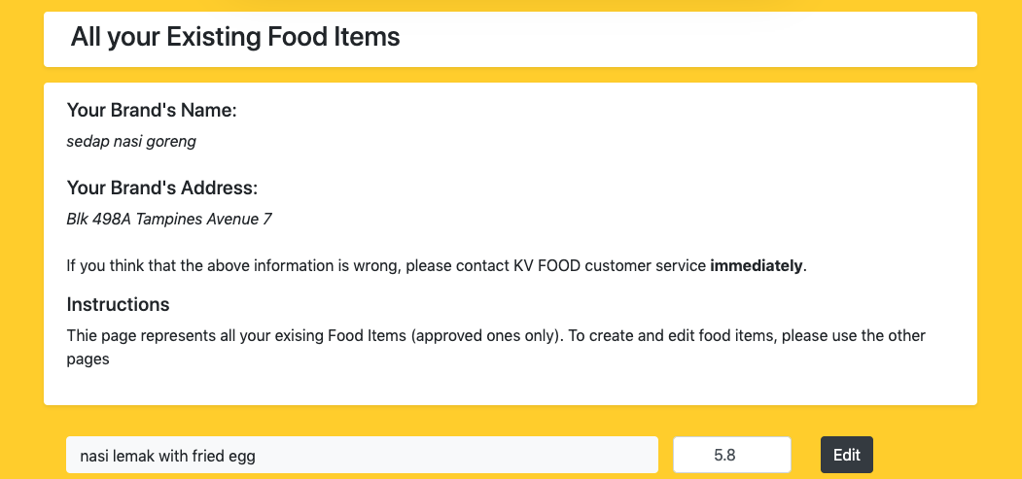

Clicking on the edit button would bring you to the following page. The brand name's address as well as the food item that they're about to edit is displayed to always ensure that the client is changing the correct menu item.

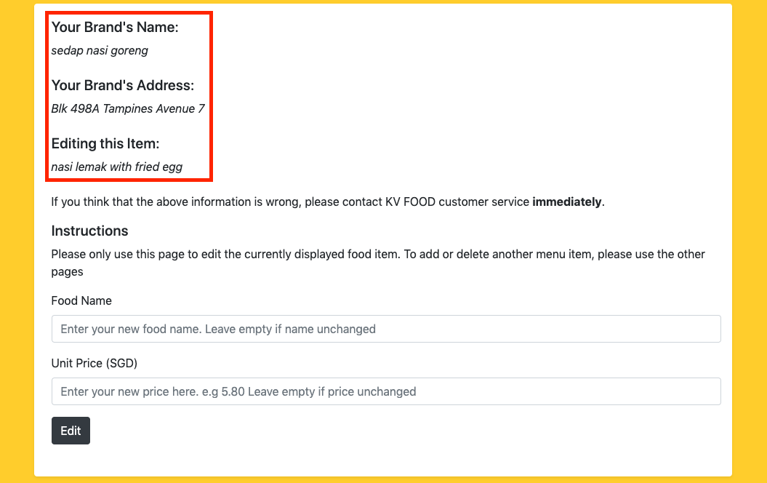

Let's assume that we want a better menu, with a change of item and therefore an added price tag. We're going to change the price to 9.99 and the food dish's name to:

*Nasi Lemak with Sambal Chicken Drumstick*

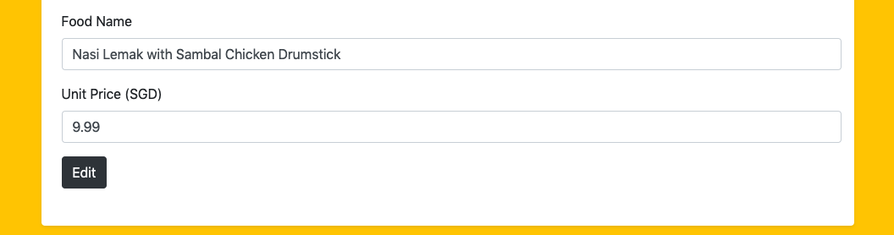

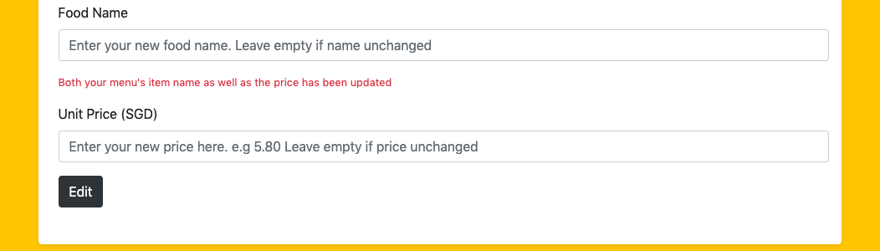

If the food dish's name as well as the price are correct, it will pass all the program's input validation algorithms and before you know it, the change is already in effect.

Here's how you can see it in action. Head back to the Edit Menu again and you'll see your previously shown

nasi lemak with fried egg changed into

**nasi lemak with sambal chicken drumstick**



1. **Deleting a Menu Item is Easy**

Don't like what you just added? Deleting is a fast, easy but also a **permanent** action.

Navigating to the delete menu on the top menu, all you have to do is press the delete button beside the dish's name.

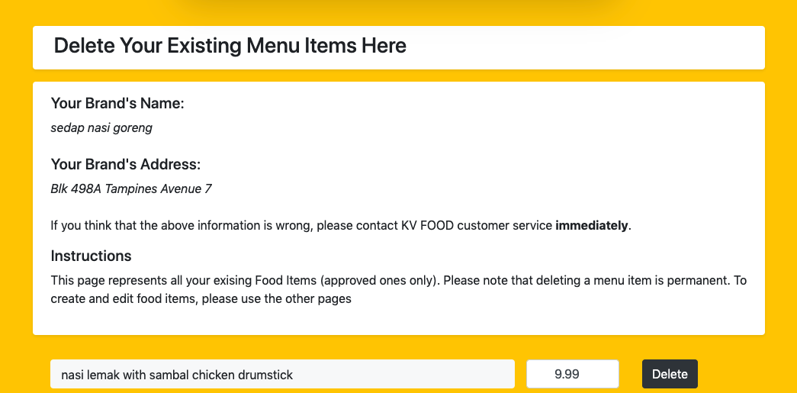

If the deletion is successful, the client will be greeted with a *"The food menu item has been successfully deleted"* message, confirming that the item has already been deleted. If you navigate to the other pages such as edit, you will no longer be able to find the dish you created.

Please be reminded again that deleting a menu item is **permanent**.

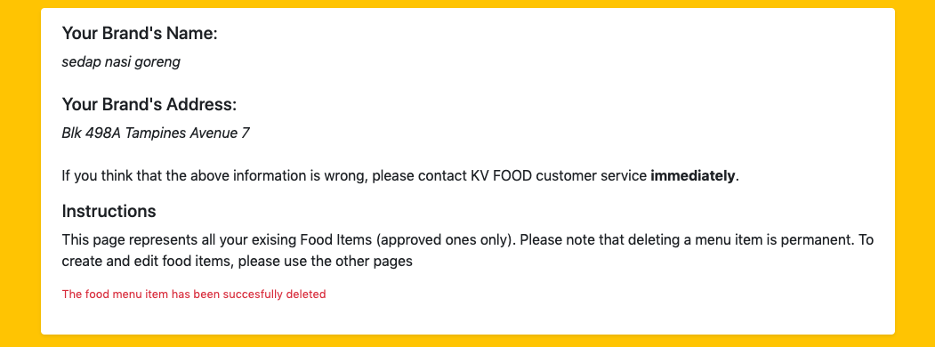

1. **Retrieval of all Food Items**

With the help of the Check Records top menu button, you can now quickly access all the food items that you have added into the server's back end system.

Of course, if you did delete the previous item, you'll probably have a blank page and probably only see something like this.

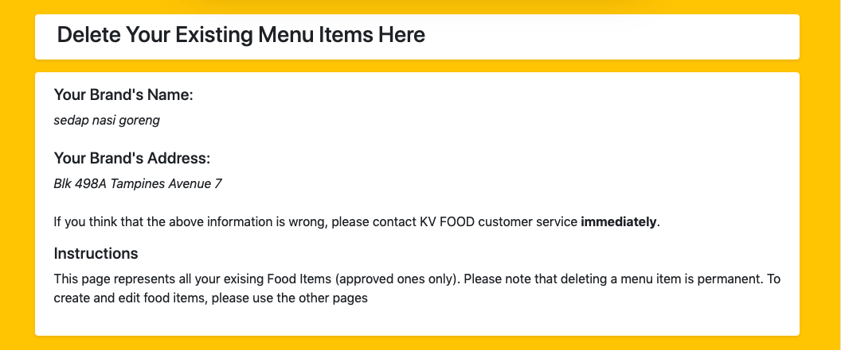

But if you had more items that were added to the server, then you probably will see something that looks more like this:

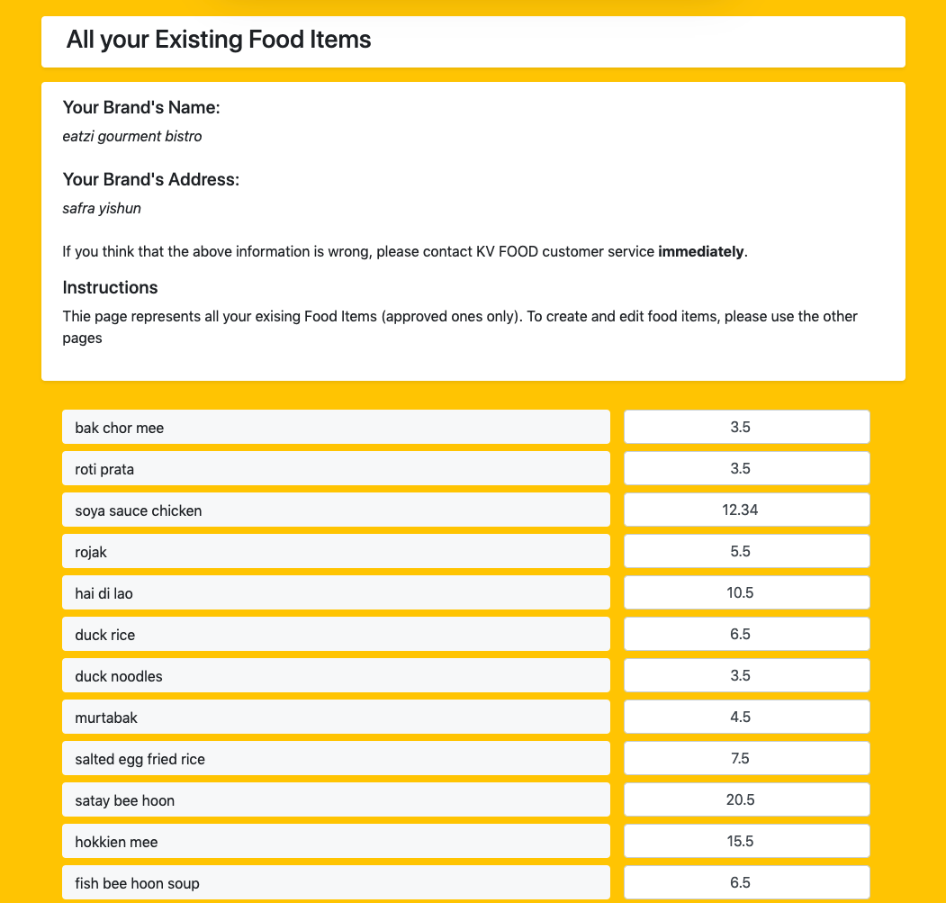

This marks the end of the instructions for the manual for the client's server. I hope you've enjoyed trying and using the client app as much as I've learnt and spent the time building it.